

Grace Academy Coventry
Curriculum Policy 2026-2027

Policy Reference: | GA-SP002
Author: | K Brehon
Applicable to: | Grace Academy Coventry
Checked by: | Governing Body
Valid from: | September 2026
Review Date: | September 2027

Contents
1. Curriculum Intent 3
2. Legislation and Guidance 5
3. Roles and Responsibilities 5
3.1 The Governing Body 5
3.2 Principal 5
3.3 Vice Principal 5
3.4 Assistant Principal: Teaching and Learning / Vice Principal 6
3.5 Heads of Department / Heads of Faculty / Lead Teachers 6
3.6 Parents and Carers 6
4. Curriculum Structure, Organisation and Planning 6
4.1 Key Stage 3 6
4.2 Key Stage 4 7
4.3 Post-16 7
4.4 Wider Curriculum 7
4.5 Extra-curricular Activities 8
4.6 Meeting Local Needs 8
4.7 Careers Guidance 8
5. Inclusion 8
Designing for Universal Access 8
6. Teaching and Learning Protocol 9
Assessment upon entry 9
6.1 Effective Teaching 11
6.2 Effective Learning 11
6.3 Literacy, Numeracy and Oracy 11
6.4 CPD and Reviewing 12
7. Assessment 12
7.1 Rationale 12
7.2 Principles 13
7.3 Minimum Expectations: Whole-school Assessment 13
7.4 Minimum Expectations: Student Feedback 14
The 4-Tiered Feedback Hierarchy 14
What must be included? 14
“DIRT” tasks: 15
Other guidance: 15
7.5 Recording and Reporting on Student Progress Data 15
8. Homework 16
8.1 Frequency and Expectations 17
8.2 The Role of the Student 17
8.3 The Role of the Form Tutor 17
8.4 The Role of the Class Teacher 17
9. Monitoring and Quality Assurance 18
10. Links with Other Policies 18

1. Curriculum Intent
At Grace Academy Coventry we place powerful knowledge at the core of our intent, our goal being to deliver a knowledge-based curriculum across all subjects. This powerful knowledge is purposefully sequenced with opportunities to revisit misconceptions and address them through explicit curriculum time and through marking and feedback.

Our key curriculum aims/intentions are to:

- Place significant emphasis upon the “powerful (substantive) knowledge” required to fully understand each subject or curriculum area. It is then sequenced in a logical, coherent fashion which builds upon prior learning. The interconnected nature of this carefully sequenced powerful knowledge will then develop the disciplinary skills required to apply this knowledge effectively. This then allows students to make sense of the unknown/unfamiliar, using sound reasoning from this vast bank of powerful knowledge they have acquired.
- Provide frequent opportunities for students to recall and retrieve this knowledge, ensuring it is retained in the long-term memory.
- Develop students’ general, and also subject-based, literacy and numeracy. Specifically, students use ambitious subject-specific terminology and phraseology when speaking and writing, leading to better outcomes. Doing this through our four pillars of literacy: oracy, reading, writing and interventions. In addition to this, Numeracy strategies fill any knowledge gaps and develop student proficiency across all subjects.

This can be distilled into the following five elements, which are referred to as “The Grace Way (Curriculum)”:

- Powerful Knowledge: Curricula are structured to ensure lessons focus rigorously on core, foundational knowledge. This essential content is vital for a deep understanding of both the immediate topic and wider interconnected concepts, and must be delivered and assessed effectively.
- Explicit Endpoints: Clearly defined by middle leaders at the curriculum design stage, these precise endpoints ensure teachers know exactly what students must achieve, understand, and produce by the end of a unit.
- Literacy, Numeracy, and Oracy: Curricula proactively integrate meaningful opportunities to develop literacy and numeracy, balancing subject-specific vocabulary with generic skills. Crucially, curriculum planning must explicitly identify and embed structured opportunities for high-quality oracy within lessons.
- Application of Knowledge: Students are provided with regular, deliberate opportunities to apply their acquired knowledge. Where appropriate, curriculum delivery explicitly maps and leverages cross-curricular links and connections to prior learning.
- Extended Independent Work: Curricula must include planned, sustained periods of independent study. These segments are designed to foster deep, rich understanding by providing students with the time and space to engage in "hard thinking" and autonomous application of knowledge.
In addition, we also aim to:

- Ensure equal access to learning for all pupils, with high expectations for every pupil and appropriate levels of challenge and support.
- Promote a positive attitude towards learning.
- Equip pupils with the knowledge and cultural capital they need to succeed in life.
- Develop pupils’ independent learning skills and resilience, to equip them for further/higher education and employment
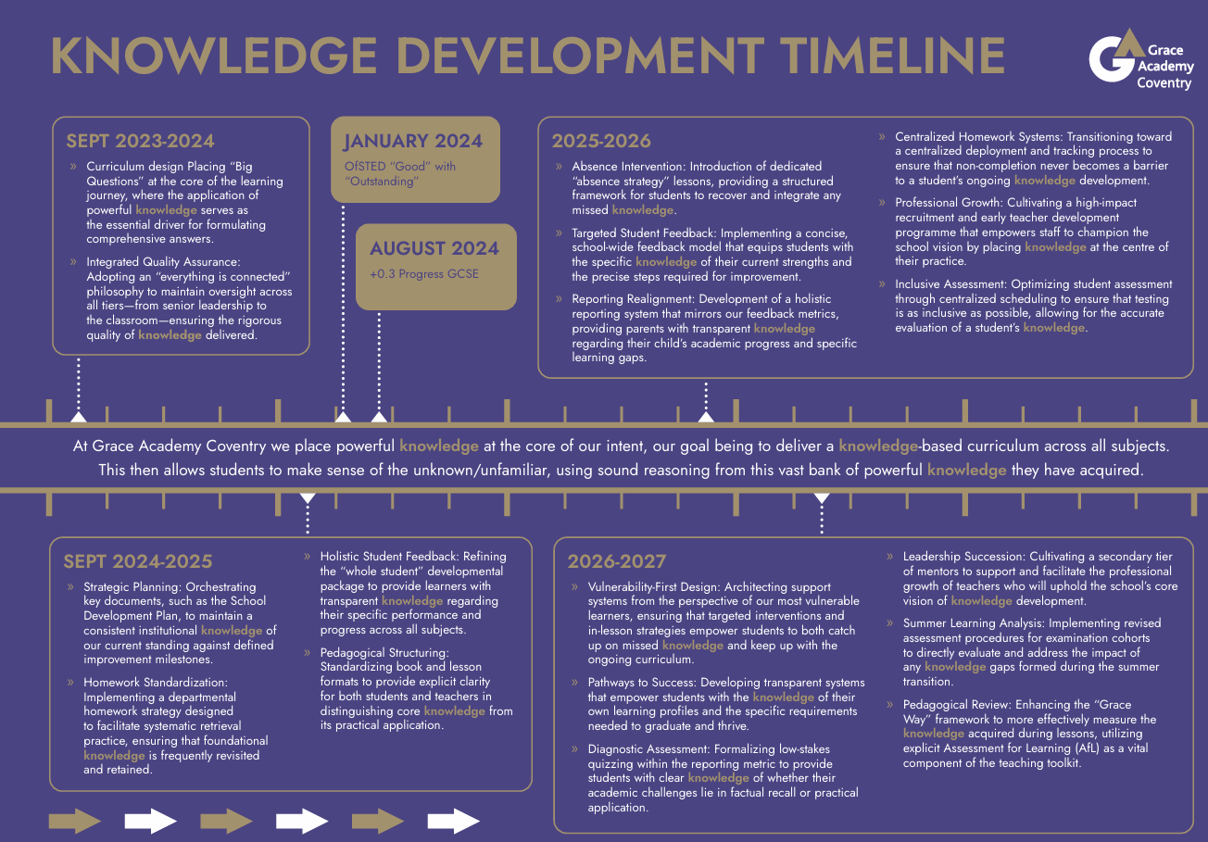

2. Legislation and Guidance
This policy reflects the requirements for academies to provide a broad and balanced curriculum as per the Academies Act 2010, and the National Curriculum programmes of study which we have chosen to follow.

It also reflects requirements for inclusion and equality as set out in the Special Educational Needs and Disability Code of Practice 2014 and Equality Act 2010, and refers to curriculum-related expectations of governing boards set out in the Department for Education’s Governance Handbook. This policy complies with our funding agreement and Articles of Association.

3. Roles and Responsibilities

3.1 The Governing Body
The governing board will monitor the effectiveness of this policy and hold the Principal to account for its implementation.

The governing board will also ensure that:

- A robust framework is in place for setting curriculum priorities and aspirational targets.
- The school is complying with its funding agreement and teaching a "broad and balanced curriculum" which includes English, Maths, Science and (subject to providing the right to withdraw) Religious Education, and enough teaching time is provided for pupils to cover the requirements of the funding agreement.
- Proper provision is made for pupils with different abilities and needs, including children with special educational needs (SEN) and vulnerable learners
- All courses provided for pupils below the age of 19 that lead to qualifications, such as GCSEs and A-levels, are approved by the Secretary of State.
- The school implements the relevant statutory assessment arrangements.
- It participates actively in decision-making about the breadth and balance of the curriculum.
- Pupils from year 7 onwards are provided with independent, impartial careers guidance, and that this is appropriately resourced.

3.2 Principal
The Principal is responsible for ensuring that this policy is adhered to, and that:

- The amount of time provided for teaching the required elements of the curriculum is adequate and is reviewed by the governing board.
- They manage requests to withdraw children from curriculum subjects, where appropriate.
- The governing board is fully involved in decision-making processes that relate to the breadth and balance of the curriculum.
- The governing board is advised on whole-school targets in order to make informed decisions.
- Proper provision is in place for pupils with different abilities and needs, including children with SEN and vulnerable learners

3.3 Vice Principal
The Vice Principal is also responsible for ensuring that this policy is adhered to, and that:

- All required elements of the curriculum, and those subjects which the school chooses to offer, have aims and objectives which reflect the aims of the school and indicate how the needs of individual pupils will be met.
- All subjects, departments and faculties have clear curricula, which reflect the Academy’s intent, local context and the most recent exam board specifications, examination requirements and statutory requirements.
- The school’s procedures for assessment and reporting to Parents/Carers meet all legal requirements.
- The effectiveness of the curriculum is regularly reviewed, with any required improvements or developments actioned. This will be shared with appropriate stakeholders.

3.4 Assistant Principal: Teaching and Learning / Vice Principal
The Assistant Principal/Vice Principal is responsible for ensuring that:

- QA processes are clear, shared with staff and have a strong curriculum focus.
- The Teaching and Learning mechanisms encouraged and promoted by the Academy are employed throughout departments and are clearly visible through lesson visits, work scrutinies and other QA processes.
- Lesson visits focus not only upon the teaching within that lesson, but all aspects of the curriculum, including the departmental/faculty intent, sequence of lessons, adaptability for vulnerable learners, assessment and future planning.

3.5 Heads of Department / Heads of Faculty / Lead Teachers
These middle leaders are responsible for ensuring that:

- All information and requirements relating to the curriculum are clearly communicated with all relevant staff, especially non-specialists.
- There are regular line management and/or departmental/faculty meetings, clearly minuted with actions and agenda items relating to curriculum.
- They are signed up to the relevant awarding boards and bodies in order to be fully informed about examination board updates, specification changes and any other information relevant to curriculum.

3.6 Parents and Carers
Parents and Carers are encouraged to:

- Engage with Parents’ Evenings, information evenings relating to their child, the options process in Year 9 and other relevant curriculum-based processes.
- Support with reading, homework/home learning, and revision.
- Communicate any queries or concerns through their child’s form tutor.

4. Curriculum Structure, Organisation and Planning

4.1 Key Stage 3
The Key Stage 3 (KS3) curriculum runs from Year 7 to Year 9 and focuses on the delivery and application of the powerful knowledge required at Key Stage 4 (KS4) and beyond. Students study the core curriculum of Maths, English and Science but also have the opportunity to experience and master subjects drawn from a wide range of specialisms. The rich and varied curriculum ensures balance across a student’s timetable. In addition, our tutor-time Ethos curriculum complements the wider curriculum in embedding key learning skills and reflection exercises into students' daily routine.
The KS3 curriculum is designed, implemented and reviewed by leaders and their teams. This is managed to ensure that key topics are delivered, relevant assessments are provided and highly effective feedback is given. Over the three-year KS3 period, students are supported so they will be in a strong position to make choices around the pathways available at KS4 and beyond. Subjects currently studied at KS3 are:

- English
- Maths
- Science
- Geography
- History
- Modern Foreign Languages
- R.E.
- P.E.
- Information Technology
- Performing Arts
- Design & Technology
- PSHE

4.2 Key Stage 4
The curriculum at Key Stage 4 (KS4) will allow students to specialise. The KS4 curriculum is a broad offering of a wide range of GCSE/equivalents in order to suit individual interests, passions and future life choices. As well as adhering to Statutory Progress 8 requirements, the curriculum at KS4 emphasises preparation with college/employment to give our young people the best start in life beyond the Academy. All students will study English Language, English Literature, Mathematics and Science (combined or separate).

In addition, their pathway choices will include the study of Humanities (Geography/History) and/or MFL. All students also have timetabled time dedicated to Physical Education. This allows students to experience a broad and balanced curriculum characterised by academic rigour and vocational opportunities.
Students will have the opportunity to choose from a broad range of subjects including Geography, History, French, Spanish, Sociology, Dance, Art, Drama, Business, Sport (BTEC), Hospitality & Catering, Digital Information Technology, Religious Studies and Health & Social Care (BTEC).
In addition to the qualifications on offer, the curriculum at Grace is designed to equip students with the knowledge, skills and resilience needed to thrive in an increasingly complex world. Through assemblies, tutor time and Ethos workshops, the Personal Development and Careers programme supports students in developing essential life skills, including communication, teamwork, leadership, problem-solving, decision-making and self-management.
Students are encouraged to reflect on their strengths and aspirations, explore a range of career pathways, and develop the confidence to make informed choices about their future. The programme includes support with work experience, post-16 applications, employability skills, interview preparation and workplace expectations. It also provides opportunities to deepen students’ understanding of emotional wellbeing, mental health, healthy relationships, online safety, financial awareness and British values, helping them to become responsible, respectful and active members of their communities.

4.3 Post-16
The Curriculum in Post-16 meets the learning needs of the cohort and wherever possible, student preferences. The Academy has developed accredited pathways at Level 3 to include A-level and BTEC qualifications. A strong Ethos programme is embedded at Post 16 level to ensure students are prepared on a Social, Moral and Cultural level in all aspects of Health and Well-being. Study programmes include 15 hours minimum per week of academic study and 1 hour per week devoted to Careers and Study Skills. All students will leave the Academy with wide ranging experiences to complement their academic achievements. Work Experience and Volunteering are essential elements in their personal development and assist in preparing them for their future at university or in the world of work. The Curriculum in Year 13 will follow through from Year 12 with the same balance of both academic and non-academic studies.

4.4 Wider Curriculum
Across the Academy, Religious Education embraces the Social, Moral, Cultural and Spiritual Dimensions and aspects of Health Education (PSHE). It also deals with behaviour, respect, courtesy, honesty, integrity, work ethic, responsibility, reliability and development of a culture of achievement as part of a planned programme including sex and relationship education. This is delivered as part of values days, tutor times and in other lessons depending upon the Academy and the specific syllabus being taught. Further details are available by contacting the Academy directly or within the Relationships and Sex Education Policy.

The five “British Values” are delivered implicitly through our tutor-time programme, assembly programme and PSHE curriculum, with levels of complexity appropriate to student ages.

4.5 Extra-curricular Activities
Extra-curricular activities are an integral part of our curriculum and are actively encouraged across all key stages. The Academy regularly reviews and updates the extra-curricular offer, which:

- Focuses upon a wide-reaching offer, incorporating sports, the arts, academics, personal development, and inclusivity.
- Is promoted and shared with staff, students and parents.
- Either extends and builds upon the current curriculum or provides additional curriculum opportunities.
- Draws upon staff expertise or utilises outside agencies.
- Is acknowledged and rewarded in line with the Academy approach for rewards.

4.6 Meeting Local Needs
Curricula are reviewed regularly in order to ensure that local needs and context are taken into account when considering intent and implementation which is particularly pertinent as part of our PSHE curriculum. Alongside this consideration, the Academy also takes into account the national needs and context, especially when considering the impact of Covid-19.

Individual subject intent statements and curriculum plans are available on our Academy website, and can be printed on request.

4.7 Careers Guidance
Careers guidance is delivered through a number of sources, including the tutor programme, PSHE lessons, external agencies, online sessions, 1-1 designated impartial careers advisor as well as our careers fayre. Events begin in KS3 and are tailored to the needs of students. The careers provision is evaluated in line with statutory requirements. Further information is available in the CEAIG policy.

5. Inclusion
Teachers champion high expectations for every learner. By leveraging the Academy’s ambitious benchmarks and utilising responsive, diagnostic assessments, educators design and deliver a rigorous, cognitively challenging, and intentionally scaffolded curriculum. Our approach ensures equitable access and a deep sense of belonging for all student communities, actively valuing the diverse perspectives of:

- Neurodivergent learners and pupils with SEND
- Students with high academic potential
- Pupils navigating socio-economic barriers or disadvantage
- Multilingual learners, including those utilizing English as an Additional Language (EAL) and students newly arrived to the UK.
- Pupils developing foundational literacy, including those with reading ages below their chronological age.
- Pupils with varying prior attainment levels

Designing for Universal Access
The curriculum is built on the principles of Universal Design for Learning (UDL). Teachers cultivate inclusive learning environments so that pupils with SEND can fully immerse themselves in every National Curriculum subject, systematically identifying and dismantling barriers to achievement.
Our curriculum celebrates multilingualism and diverse starting points as assets. For students developing proficiency in English or working to close literacy and reading gaps, learning is designed to accelerate vocabulary acquisition, dismantle complex texts through high-impact scaffolding, and empower every student to be a leading, active participant in the school community.
When establishing academic targets for students with SEND, foundational literacy gaps, or profound EAL needs, the Academy rejects low expectations. We set ambitious, high-flight targets rooted in what these students can achieve with the right support. However, target-setting is treated as a dynamic, ethical process rather than a rigid statistic; we carefully evaluate the psychological and emotional impact of these benchmarks to ensure they inspire confidence rather than anxiety.

To ensure target-setting serves as a tool for genuine progress:

- Holistic Assessment: Targets are informed by diagnostic data that isolates a student's actual cognitive ability from their current reading or language barriers.
- Responsive Re-calibration: If a target or a reading age metric becomes a barrier to a student's sense of self-efficacy, the Academy will proactively adapt and amend these benchmarks.
- Co-Constructed Pathways: Any adjustments to targets are never made in isolation. They are co-designed alongside the student, parents, and carers to maintain transparency and ensure everyone is invested in a realistic yet highly aspirational path forward.

6. Teaching and Learning Protocol
In creating a knowledge-based curriculum across all subjects, the Academy recognises the importance of students retaining and applying the subject matter they are taught. As a result, teaching and learning approaches should be simplistic, highly effective and support a systematic and sequential delivery, whilst allowing for misconceptions to be revisited and addressed when required.

As a default position, quality-first teaching approaches should be challenging and aspirational for all students, with scaffolding for those requiring additional support. The Academy strongly believes the following teaching and learning principles, applied consistently and effectively over time and supported by appropriate assessment methodology, lead to students retaining and demonstrating knowledge over longer periods.

Assessment upon entry
To ensure all learners thrive from day one, Grace Academy conducts comprehensive baseline assessments at the start of each student’s educational journey. Where appropriate, these diagnostic screenings include: reading age, numeracy levels, handwriting, PASS (Pupil Attitudes to Self and School), dyslexia, and dyscalculia. This proactive approach allows us to rapidly identify and mitigate potential barriers to learning, ensuring students are seamlessly connected to our extensive, targeted intervention programmes.
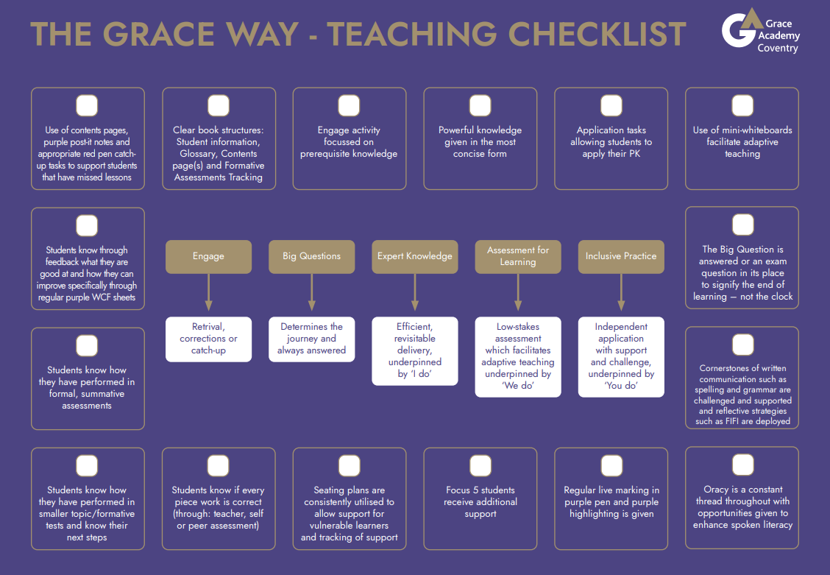

6.1 Effective Teaching
- Engage: Low stakes retrieval questions testing prior knowledge. Corrections of previous work. Or, the time where students catch-up on missed work.
- Big Questions: Each lesson has a “Big Question” which relates directly to the powerful knowledge required in order to progress, and the knowledge delivered in that lesson/sequence of lessons allows students to answer this question – it signifies the end of learning.
- Expert Knowledge: Teachers, under the guidance of their middle leader, are best placed to make decisions upon the best possible methodology and delivery format for the expert knowledge students need to know. This is underpinned by the ‘I do’ principle.
- Assessment for Learning: Low-stakes assessment which facilitates adaptive teaching underpinned by ‘We do’.
- Inclusive Practice: Independent application with support and challenge, underpinned by ‘You do’.

The Academy also promotes the following approaches when considering Teaching and Learning:

- The continued application of “cognitive load theory” so that information is presented in a manageable way.
- Frequently setting tasks which require students to learn and apply knowledge independently, including the use of revision and retention strategies.
- Incorporating the use of knowledge organisers, critical content or other alternative resources so students are encouraged to become skilled in drawing out relevant “powerful knowledge”.

6.2 Effective Learning
The learning aspect of teaching and learning expects students to meet a number of common standards throughout their journey from KS3 to Post-16.

- We are on time: Prompt arrival is vital to the learning experience. Students are expected to show the respect, diligence and organisational skills to be able to meet deadlines and take ownership of their learning.
- We are prepared: Students are expected to bring the correct equipment to lessons (their ‘Grace 5’. Moreover, ‘preparation’ also assumes that students are mentally prepared to enter the learning environment in a calm, respectful manner and are ready to perform to the best of their ability.
- We respect our community: Our Academy is at the heart of our community. Respecting the community means understanding responsibilities and treating every aspect of the learning environment with respect. This includes staff, students, visitors, books, equipment and the building itself.
- We Listen: Knowledge can only be imparted if students are listening. It is imperative that students understand when to contribute and when to listen to the contributions of others whilst displaying Mutual Respect.
- We Participate: Students are encouraged to get the most of the learning experience by being active in the classroom. Participation means contributing to discussions, being inquisitive and seeking clarification.

6.3 Literacy, Numeracy and Oracy
When leaders are designing curricula, opportunities to develop literacy and numeracy should be in-built and are to be clearly evident during implementation. Curriculum delivery should also be informed and supported by the literacy and numeracy strategy documents. It is the responsibility of all leaders associated with these to ensure both the literacy and numeracy strategy are shared and understood by all relevant staff, and the effectiveness and impact are evaluated. Further information can be found in our literacy and numeracy strategies.

We place a strong emphasis on cultivating high-quality oracy, ensuring our young people are explicitly taught the most effective ways to speak and listen. In practice, we utilise our structured VOICE (speaking) and FOCUS (listening) strategies to develop and refine these foundational communication skills. Furthermore, our curriculum is deliberately mapped to provide structured opportunities across all subjects where students can purposefully deploy these skills in high-impact, positive discussions.

6.4 CPD and Reviewing
The Academy recognises the importance of the role CPD plays when considering teaching and learning, and will:

- Share the teaching and learning priorities with all staff, ensuring there is full clarity around each element.
- Inform students and parents of the priorities, so they are able to engage effectively.
- Provide ongoing CPD and bespoke training during directed time, focusing upon best practice and how to employ strategies for maximum impact.
- Allow staff to feed back to ALT regarding the Teaching and Learning protocol, via middle leaders, working parties, line management and department meetings.
- Continue to engage with all recent theory, literature and evidence-based research around successful teaching and learning approaches, employing wherever relevant or appropriate.
- Ensure workload and staff wellbeing are paramount in all decisions relating to teaching and learning.

The effectiveness of the Teaching and Learning protocol will be measured and assessed as part of the Academy’s monitoring and Quality Assurance processes. In addition, ALT and governance will be kept informed as to the effectiveness of the protocol and impact upon student outcomes. Effectiveness can be measured by, but not limited to, the following factors:

- Student outcomes in terminal examinations at KS4 and Post-16
- Student outcomes in unit assessments at KS4 and Post-16
- Student outcomes in externally-validated assessments at KS3, KS4 or Post-16
- Evidence of student work produced
- Careers destination data
- Post-16 retention numbers
- University destination data

7. Assessment

7.1 Rationale
Assessment is an integral part of any curriculum and reflects the formal and informal judgements made by teachers and students about standards of work, and is measured, where appropriate, against nationally agreed criteria. Formative, diagnostic assessment is used throughout the year to inform teaching and learning and identify any areas for improvement. Summative assessment is used to evaluate learning and progress by awarding a grade of attainment, or percentage, to a student. This will enable the Academy to assess student progress in a coherent and consistent way, and subsequently facilitate higher achievement for students across all levels of ability. Work undertaken by students requires feedback (written or verbal) in order to enable them to know and understand the progress they are making, with the next steps required so they can continue to improve. It will also inform staff as to where there are gaps in students’ knowledge and understanding, or misconceptions which need addressing.

Summative Assessments are given periodically to determine at a particular point in time what students know and do not know, and to identify any gaps in learning, individually or collectively. More robust and informative examples of summative assessment include:

- GCSE examination papers
- Interim assessments
- End-of-unit tests
- End-of-term exams / assessments (AP’s)

Summative assessments are a means to measure, at a particular point in time, student learning relative to specification. It is currently used towards the end of a term, in accordance with the Tove Learning Trust (TLT) Assessment Policy. Summative assessment is used to quantify achievement, to reward achievement and to provide accurate data for the whole school analysis including school reports. Therefore, the robustness, validity and reliability of summative assessments are of the greatest importance.

Formative assessment is an integral part of high quality, day-to-day teaching and learning. When incorporated into classroom practice, it provides the information needed to adjust teaching and learning and will affect what the student and the teacher does next. In this sense, formative assessment informs both teachers and students about student understanding or possible misconceptions at a point when timely adjustments can be made. It is therefore entirely reasonable for teachers to move away from schemes of work or the planned sequence in which knowledge is to be delivered on those occasions where it is clear students’ learning in a particular area needs to be reinforced or re-visited. These adjustments help to ensure students achieve targeted learning goals within a set time frame. Although formative assessment strategies appear in a variety of formats, there are some distinct ways to distinguish them from summative assessments in that they are more “low-stakes”, and do not take the form of the summative assessments listed above.

7.2 Principles

- The focus of any written and/or verbal feedback must be to give students a clear understanding of how well they have gained knowledge, concepts and skills, address misconceptions, correct spelling or non-subject-specific literacy and then explain what needs to be done to extend their learning (what they are good at and how they can improve). This applies to all formative AND summative assessments undertaken.
- Students' assessment of their own and their peers’ progress and attainment is a central function in the learning process.
- Time will be built into lessons for students to reflect on and respond to teacher marking and feedback (”DIRT”).
- Whole-class marking will help students to progress in their learning and will be meaningful, manageable and motivating.
- The marking/feedback strategy/strategies used are designed to ensure teacher workload is minimised.
- All teachers will be responsible for the continuous assessment of students and for the accurate and timely completion of any required data drops, mark sheets, reports or other related documents.
- Formal assessments will be signposted in curriculum plans and schemes of work.
- Formal assessments will cover all attainment targets appropriate to the subject/unit of work either currently being delivered or which has been previously delivered this academic year, therefore ensuring assessment is cumulative.
- In Key Stage 4 and Post-16, the school will provide opportunities for formal summative examinations (e.g. mock exams) at least once a year for selected subjects, year groups or groups of students.
- All teachers will provide regular opportunities for self‐assessment, and wherever appropriate, peer assessment.
- All subjects and departments will use assessment folders, which for each student contains the summative assessments used to measure progress and attainment. These will be regularly updated as per the departmental instruction.

7.3 Minimum Expectations: Whole-school Assessment

- For Key Stage 3: Three Summative assessments a year in accordance with the school assessment calendar – one per term.
- For Key Stage 4 and Post-16: Three Summative assessments a year in accordance with the school assessment calendar – one per term, or in line with the TLT Assessment calendar.
- For all key stages: Summative assessments, once completed are to be kept until the end of key stage and stored in a folder.
Departments/faculties will determine whether assessments outside of the set summative assessment windows mentioned above should be summative or formative, but some form of assessment shared across the faculty/department is required in order to provide student feedback.
Unless part of a formal mock examination period, individual faculties and departments may decide when assessments take place within each set assessment period. Assessments however must be completed and marks recorded on G4S ahead of scheduled data captures.

7.4 Minimum Expectations: Student Feedback

Grace Academy Coventry has minimum expectations in relation to students receiving feedback across a period of learning. In line with the Department for Education Teachers’ Standards, ‘teachers must give pupils regular feedback, both orally and through accurate marking’ Therefore, it is reasonable that colleagues should expect to have their students’ books/work/assessments checked during lesson visits, QA walks, observations or as part of a work‐scrutiny by the Head of Department/Faculty or the Academy Leadership Team.

All student work—whether in exercise books or dedicated workbooks—must display clear, recent evidence of formative assessment. This includes self-assessment (SA), peer assessment (PA), and impactful teacher live marking. To ensure this feedback drives progress efficiently, our core methodology relies on structured Whole-Class Feedback Sheets, allowing teachers to address common misconceptions and communicate targeted, actionable guidance to all learners simultaneously.

The 4-Tiered Feedback Hierarchy
To ensure assessment remains both robust and sustainable, the frequency of whole-class feedback is proportionally scaled to curriculum allocation and overall lesson volume. This model distributes teacher workload equitably while ensuring students receive feedback that matches the structural intensity of their courses.

- Tier 1 (Highest Frequency): This tier demands the most frequent feedback, directly matching the high volume of contact time embedded within the timetable. It applies universally to all Key Stage 5 subjects, as well as Key Stage 4 Core subjects, specifically English, Maths, and Science.
- Tier 2: This tier covers Key Stage 4 Option subjects. Feedback is delivered at regular intervals that align naturally with the curriculum weighting and lesson allocation assigned to these elective choices.
- Tier 3: This tier applies to Key Stage 3 Humanities—including Geography and History—as well as Key Stage 3 Modern Foreign Languages (MFL), matching the standard curriculum footprint of these foundation subjects.
- Tier 4 (Targeted Frequency): This final tier reflects a lighter curriculum footprint. For Key Stage 3 Creative and Practical Arts (Music, Drama, Art, and Design Technology), alongside PE and PSHE, feedback is spaced proportionally to reflect their lower proportion of overall lesson time, meaning whole-class feedback may only occur once per term.

What must be included?
The underpinning principle of this framework is that every student should interact with their feedback sheet and immediately understand both their areas of strength and their clear next steps for improvement. To support this process, whole-class feedback acts as a targeted diagnostic tool, allowing teachers to explicitly identify and address widespread misconceptions, mechanical errors, and gaps in core subject knowledge. It also serves as a vehicle for celebrating both individual and group success, highlighting tangible progress and effort across the cohort.

To foster a collaborative culture of high expectations, teachers may sensitively feature exceptional student work on the feedback sheet to serve as a high-quality model for the rest of the class. Furthermore, the feedback process facilitates the development of accurate literacy across all disciplines by addressing spelling, punctuation, grammar, and non-subject-specific communication errors. Finally, to promote student agency and deeper thinking, feedback explains precisely how students can extend their learning, often by providing them with a choice of relevant, high-challenge extension pathways tailored to their current progress.

“DIRT” tasks, or specifically assigned “DIRT” tasks for individual students.

“DIRT” tasks:
- “DIRT” tasks following an assessment may be either progressive or reflective, but should consider the needs of all students and be reflective of the requirement to improve that specific assessment.
- Students are expected to engage with, and complete their “DIRT” tasks, and are to be given designated time during lessons in which to do so.
- Engagement in “DIRT” tasks should be recognised through either self-assessment (SA), peer assessment (PA) or teacher acknowledgement marking.
- When the curriculum does not require written or tangible work to be created, there is not a requirement for a written “DIRT” task. This will apply mostly in KS3 and in subjects such as PE, Music, Drama and Technology. More detail is included in the Non-examination assessment policy.

Summative (or “AP”) assessments also require group feedback as outlined above. However, more individualised teacher feedback on the assessment paper is required wherever necessary.
Individual Positive feedback is to be given when work shows the student has done well.

Wherever teachers have written comments they should be in purple pen and class feedback sheets should be on lilac paper, stuck into books or within assessment folders (wherever the assessed task is found).

Other guidance:

- Teachers must insist on the very highest standards of presentation for students’ work in books and folders at all times. Individual faculties may use professional discretion to address specific needs within their subject area. Any specific guidelines for presentation will be created and shared by each department or faculty.
- Percentages and/or grades should be added to an individual student’s feedback comments following an AP assessment.
- Any homework set will be marked. This may be done through teacher assessment, peer assessment, self-assessment or active verbal feedback.
- If ‘active verbal feedback’ is given within lessons, this does not have to be recorded but students are expected to act upon the feedback. Evidence of verbal feedback should be clear during lesson visits and observations (where appropriate).
- Self and peer assessment is to be used as appropriate. In SA and PA, students will be made aware of the success criteria in advance, and will have received guidance regarding how to assess.
- When a course is either nearing its completion, or has been completed in Year 11 or Year 13, teachers may use their professional discretion in terms of assessments and how they undertake the marking and feedback of students’ work. Teachers should still ensure that regular and precise feedback is given during final examination preparation, whilst adapting it to support in the most appropriate manner.
- Faculties are actively encouraged to share good practice.
- When considering how to give feedback to students, departments must adopt this default approach outlined above, except in cases where subjects or specific examination board requirements prohibit this approach. This applies specifically to some elements of vocational subjects. In those cases, Line Managers will work with Heads of Department/Faculty or lead teachers in order to find an appropriate solution.

7.5 Recording and Reporting on Student Progress Data
The accurate and timely entry of meaningful student progress data is of paramount importance to both the validation of the assessment process, and ensuring an effective curriculum. The Academy will share this information with students, staff, Parents/Carers, Leaders and Governors in the most appropriate format for each stakeholder or groups of stakeholders.

All staff have access to Bromcom mark sheets for their allocated classes. These mark sheets will include information regarding prior attainment, SEND, Disadvantaged (as defined by the DfE) and other relevant student groups. All staff are responsible for ensuring that the mark sheet entries for their classes are kept up to date to allow for data snapshots throughout the year, with heads of department/faculty overseeing the entry of their departmental data.

The Academy will report summative assessment data and progress towards targets to Parents/Carers and students in the following manner:

- Students’ aspirational targets will be generated through FFT5 (Fischer Family Trust) wherever Key Stage 2 data allows. In cases where Key Stage 2 data is not available, the Academy will set aspirational student targets using internal data or assessments.
- For KS3 reports, students receive a statement against their end of Key Stage 4 target band which is either: performing significantly below target, performing below target, performing at target or performing above target.
- For KS4 reports, a student’s current attainment grade is measured against their end of Year 11 target.
- For KS5 reports, a student’s current attainment is measured against their end of Year 13 target.
- For vocational courses, a student’s current attainment may be difficult to determine if they have incomplete NEA or coursework and this would mean assigning a grade not reflective of that student’s holistic attainment and progress towards a grade. In these cases, staff are to record a “best fit” grade with the support of their line manager or Vice Principal.
- A small minority of students may be set targets of grade 1 or 2, dependent upon individual circumstances and where this would still represent an appropriately aspirational target in that case.

Full academic reports, issued once per academic year, provide a comprehensive overview of a student’s holistic progress and development. These reports offer detailed commentary on attendance, behavior, and overall engagement in both lesson-based and home learning. Crucially, they include a diagnostic curriculum assessment designed to clearly inform parents and carers of the specific areas of the curriculum where their child is secure, alongside identified areas requiring further development and support.

The Vice Principal is responsible for target setting, and must be consulted in any case where target amendments are requested. Targets cannot be amended without authorisation from the Vice Principal.

8. Homework
Homework, or “learning outside of lessons” is work to be done outside the timetabled curriculum, and is a key driver in supporting and raising student achievement. It contains an element of independent study in that it is not usually directly supervised by a teacher. We feel that homework enhances student learning, improves achievement and develops students' study skills and as such is an integral part of the curriculum. As a result, it requires careful planning and integration into the scheme of work of each curriculum area, with subject areas given the autonomy to decide upon the most suitable format and delivery method for them. Homework is designed to facilitate the following three strands: closing of gaps of, consolidation of and acquirement of knowledge.

Whichever method is selected, homework must perform one (or more) of the following functions to underpin those three strands:

- Consolidate knowledge and extend work covered in class or prepare for new learning activities.
- Access resources not available in the classroom.
- Develop research skills and acquiring knowledge
- Have an opportunity for independent work.
- Show progress and understanding of previously acquired knowledge
- Provide feedback in the evaluation of teaching.
- To enhance their study skills e.g. planning, time management and self-discipline.
- To take ownership and responsibility for learning.
- Engage parental co-operation and support.
- Create channels for home school dialogue.

8.1 Frequency and Expectations
The frequency of homework set may vary between departments, but should follow these principles:

- Homework is part of each subject’s curriculum plan, and will be assigned accordingly.
- Alongside subject-specific homework, KS3 students are to engage in reading homework as set by their form tutor. This is where students continue to read the reading age-appropriate book they are issued in school.
- Wherever homework is completed, teachers should acknowledge the completion. This could be through any of the following mechanisms:
  - Utilising the centralised homework tracking mechanism
  - Marking the work
  - An automated response, acknowledgement of completion or score (if completed online)
  - Awarding positive behaviour points
  - Providing a comment on the work
  - Giving group feedback
- When homework is not completed, teachers should initially support the student and ensure the tasks set meet the student's needs. If this is so, then appropriate sanctions could be issued in line with the general school behaviour policy.

8.2 The Role of the Student
- To ensure instructions for the task and deadline date are accurately recorded in planners (SEND students or students with profound EAL needs may need additional support).
- To ensure that homework is completed and handed in to meet the deadline.
- To attempt completion to the best possible standard.
- In case of any difficulties or barriers, to inform the class teacher of any difficulties at the first available opportunity.

8.3 The Role of the Form Tutor
- To include homework in their approach when providing student care.
- To see that homework is being regularly set and recorded, and flag any concerns to leaders within the Academy (in cases where homework does not appear to be set) and/or Parents/Carers (in cases where homework is not being recorded).
- To check that the diary is being signed by the Parent/Carer.
- To note and respond to any homework-related comments written in planners by parents.

8.4 The Role of the Class Teacher
The class teacher controls the direction of homework and the nature of tasks undertaken. The teacher will:

- Set homework according to the given curriculum plan.
- Give full and comprehensive instructions.
- Set deadlines for completed work and ensure that they are met.
- Acknowledge all homework promptly.
- Provide appropriate levels of scaffold or support for SEND students or students with profound EAL needs.
- Inform the middle leader, form tutor and Head of Year, as appropriate, when problems arise.

9. Monitoring and Quality Assurance
Governors monitor whether the school is complying with its funding agreement and teaching a “broad and balanced curriculum” which includes the required subjects, through:

- Teaching and learning reports in governing body minutes and meetings.

The Vice Principal and Assistant Principal for Teaching and Learning monitor the effectiveness of curricula throughout the Academy by:
- Planning and carrying out work scrutinies.
- Conducting lesson visits and/or observations.
- Ensuring a rigorous and effective QA calendar and corresponding cycle.
- Creating reports, which are shared with ALT and Governors.
- Considering examination results, at both KS4 and Post-16.
- Taking staff, student and parental feedback.

The Academy Leadership Team monitors the way their subject is taught throughout the school by:
- Engaging effectively in all QA systems, through regular line management meetings and visiting lessons along with middle leaders.
- Ensuring they are aware of performance-related data within their line managed subjects, focusing upon attainment/assessment data, behavioural, and attendance-related statistics.

Heads of department/subject leaders/lead teachers also have responsibility for:
- Engaging effectively with all QA systems.
- Monitoring the way in which resources are stored and managed.

This policy will be reviewed every two years by the Vice Principal. At every review, the policy will be shared with the full governing board.

10. Links with Other Policies
This policy links to the following policies and procedures:

- Non-examination assessment policy
- SEN policy
- Equality information and objectives
- Internal Literacy and Numeracy strategy
- CEAIG policy
- Pupil Premium strategy document

